Programming Exercise 6
Name: Slade Miller
Course: COP 2373
Description
The Personal Information Validator is a Python program that uses regular expressions to validate phone numbers, Social Security numbers, and ZIP codes. The program asks the user to enter each type of information and then displays whether each value is valid or invalid.
Function: validate_phone()
The validate_phone() function checks whether a phone number matches one of the accepted phone number formats.
Parameters
- phone – The phone number entered by the user or provided during testing.
Variables
- pattern – A regular expression used to validate the phone number.
Steps
- Receive the phone number as a parameter.
- Create a regular expression that accepts common phone number formats.
- Use the regular expression to compare the phone number.
- Return whether the phone number matches the pattern
Return Value
Returns True if the phone number is valid and False if it is invalid.
Accepted Examples
- 123-456-7890
- (123) 456-7890
- 1234567890
- 123.456.7890
Function: validate_ssn()
Description
The validate_ssn() function checks whether a Social Security number matches the expected format.
Parameters
- ssn – The Social Security number entered by the user or provided during testing.
Variables
- pattern – A regular expression used to validate the Social Security number.
Steps
- Receive the Social Security number as a parameter.
- Create a regular expression that checks for nine digits.
- Allow the standard hyphenated format.
- Use the regular expression to compare the Social Security number.
- Return whether the Social Security number matches the pattern.
Return Value
Returns True if the Social Security number is valid and False if it is invalid.
Accepted Examples
- 123-45-6789
- 123456789

Function: validate_zip()
Description
The validate_zip() function checks whether a ZIP code is in a valid United States ZIP code format.
Parameters
- zip_code – The ZIP code entered by the user or provided during testing.
Variables
- pattern – A regular expression used to validate the ZIP code.
Steps
- Receive the ZIP code as a parameter.
- Create a regular expression that checks for five digits.
- Allow the optional ZIP+4 format.
- Use the regular expression to compare the ZIP code.
- Return whether the ZIP code matches the pattern.
Return Value
Returns True if the ZIP code is valid and False if it is invalid.
Accepted Examples
- 34231
- 34231-1234
- 90210
- 10001

Function: run_tests()
Description
The run_tests() function tests the three validation functions using both valid and invalid examples. This verifies that the regular expressions are working correctly.
Parameters
None.
Variables
- valid_phones – A list containing valid phone number examples.
- invalid_phones – A list containing invalid phone number examples.
- valid_ssns – A list containing valid Social Security number examples.
- invalid_ssns – A list containing invalid Social Security number examples.
- valid_zips – A list containing valid ZIP code examples.
- invalid_zips – A list containing invalid ZIP code examples.
- phone – Used to loop through the phone number test lists.
- ssn – Used to loop through the Social Security number test lists.
- zip_code – Used to loop through the ZIP code test lists.
Steps
- Create lists containing valid and invalid phone numbers.
- Test each phone number using validate_phone().
- Display the results.
- Create lists containing valid and invalid Social Security numbers.
- Test each Social Security number using validate_ssn().
- Display the results.
- Create lists containing valid and invalid ZIP codes.
- Test each ZIP code using validate_zip().
- Display the results.
Return Value
The function does not return a value. It displays the test results on the screen.
Function: main()
Description
The main() function is the primary function of the program. It gets a phone number, Social Security number, and ZIP code from the user and determines whether each value is valid.
Parameters
None.
Variables
- phone – Stores the phone number entered by the user.
- ssn – Stores the Social Security number entered by the user.
- zip_code – Stores the ZIP code entered by the user.
Steps
- Display the program title.
- Ask the user to enter a phone number.
- Ask the user to enter a Social Security number.
- Ask the user to enter a ZIP code.
- Send the phone number to validate_phone().
- Display whether the phone number is valid or invalid.
- Send the Social Security number to validate_ssn().
- Display whether the Social Security number is valid or invalid.
- Send the ZIP code to validate_zip().
- Display whether the ZIP code is valid or invalid.
Return Value
The function does not return a value.

Program Testing
The program was tested using multiple valid and invalid examples for each type of information.
Phone Number Testing
Valid:
- 123-456-7890
- (123) 456-7890
- 1234567890
- 123.456.7890
Invalid:
- 123-456-789
- 123-45-67890
- abc-def-ghij
- 12345678901
Social Security Number Testing
Valid:
- 123-45-6789
- 123456789
Invalid:
- 123-456-789
- 12-345-6789
- 123-45-67890
- abcdefghijk

ZIP Code Testing
Valid:
- 34231
- 34231-1234
- 90210
- 10001
Invalid:
- 3423
- 342311
- 34231-123
- Abcde

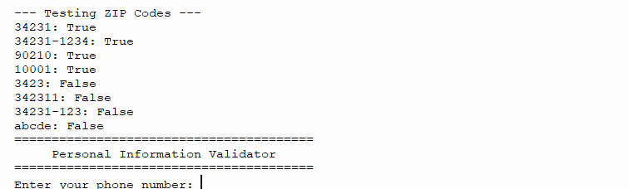

https://github.com/slade963/COP2373

